POLICY ACTION NEEDED TO MAKE
A TEMPORARY BOOST STRUCTURAL

ECONOMIC SITUATION

• Supported by lower oil prices, a weaker Euro exchange rate and ECB policy action, Europe's economic growth prospects have slightly improved; we forecast GDP to grow by 1.9% in the EU in 2015, and by 1.6% in the Euro Area (compared to 1.7% and 1.2% in our Autumn 2014 Outlook).

• We expect the recovery to slightly strengthen in 2016, when we foresee GDP growth of 2.1%
in the EU and by 1.9% in the Euro Area.

• Domestic demand should gradually replace net exports as the main growth driver. Amidst signs of growing consumer confidence we expect EU private consumption growth of 1.9% in 2015. Businesses are reporting the highest demand for finance since the start of the crisis and we expect investment growth of 2.8% this year.

• While remaining at high levels, unemployment is expected to fall a little; to 9.5% (from 9.8%) in the EU and 10.6% (from 11.3%) in the Euro Area in 2015, and to 9.0% (EU) and 10.1% (EA) in 2016. Country differences still remain high.

• Inflation is forecast to remain low in 2015 but to gradually increase to 1.5% for the EU and 1.2% for the Euro Area in 2016, as the effect of higher import costs and stabilising energy prices work though.

• The 12% depreciation in the Euro over the last year could boost growth by up to an extra
0.5% this year and by up to 0.4% in 2016. But the impact will not be uniform across the Euro Area. Strong trade links with Russia mean the exchange rate fall has been much less significant in Finland
and the Baltics, in contrast to Ireland with strong US links. Countries such as Cyprus and Greece
also have a much lower share of exports going outside the EU than Belgium and the Netherlands.

POLICY CONSIDERATIONS

• The window of opportunity created by the weaker euro, lower oil prices and ECB action must not be wasted. However, these factors alone cannot be the basis for growth in the long-run. Member States must press ahead with the implementation of ambitions structural reform programmes to support competitive product and services and labour markets, towards the aim of securing soon tangible results in the performance of job markets.

• Member States must demonstrate their commitment to fiscal reforms by adhering to EU budgetary rules, drawing on the flexibility embedded within the Stability and Growth Pact and the Commission’s new guidelines. In order to achieve a more growth-friendly composition of fiscal policies, lowering the tax burden in a budget-neutral way and cutting expenditure in unproductive areas is essential.

• A failure to properly balance stability and growth considerations regarding financial regulation risks becoming an increasing constraint as businesses demand for finance picks up with the economy. In addition, as part of its broader investment plan, the EU needs to unlock alternatives to bank finance and improve the business environment. In this context, we welcome the Commission’s Capital Markets Union Green Paper.

• A successful deal on Transatlantic Trade and Investment Partnership (TTIP) can boost EU’s growth and job creation. In the current situation it would also allow EU exporters to benefit from the lower exchange rates of EU currencies against a strong US Dollar.

WHAT IS THE ECONOMIC OUTLOOK?

The Economic Outlook twice a year provides a business insight into recent and projected economic developments in Europe, based on a survey of BUSINESSEUROPE member federations.

Answers to this autumn’s questionnaire were received in March 2015.

FOR FURTHER INFORMATION:

Economics Department
James Watson, Director and Frederik Lange, Adviser
Tel: +32 (0)2 237 65 26 - E-mail: f.lange@businesseurope.eu
BUSINESSEUROPE Av. de Cortenbergh 168 – 1000 Brussels

1. OVERVIEW

The economic recovery shows some gradual improvement

Over the last 6 month EU businesses have experienced some improvements in the economic situation, although the recovery remains fragile and varied across the EU . In particular, consumer confidence increased sharply since last September and increased consumer spending is likely to drive future growth.

Lower oil prices, a weaker euro exchange rate and the European Central Bank’s (ECB’s) extension of asset purchases have all contributed to the moderate rises in consumer and business confidence we have seen in recent months.

Against this background, we expect (table 1) real GDP growth for the EU to be 1.9% in 2015 (0.2% higher than our Autumn 2014 Forecast) and 2.1% in 2016. Reflecting the fact that the improvement since the autumn has been more focussed on the Euro Area, we now expect growth of 1.6% in the single currency area on 2015 (a rise of 0.4% on the autumn), with 1.9% in
2016.

However, the improving growth trajectory is to a certain extent the result of fortunate circumstances such as the decline in oil prices and the weaker euro. To maintain a stronger recovery over the long-term, it is important to address structural obstacles to growth and improve European competitiveness. There is still a strong divergence with the growth prospects in Europe and those in the United States (3.1% for both 2015 and 2016, according to the IMF). Finally, geopolitical risks such as the deteriorating EU -Russia relations as well as the situation in Greece pose a major risk to the outlook.

Table 1 More positive economic prospects for the EU and Euro area
BUSINESSEUROPE main forecast
 |  | EU28 |  |  |  | Euro area
Main Variables |  | 2015 |  | 2016 |  | 2015 |  | 2016
Real GDP (annual % growth)  Inflation (%) Unemployment (%)  government net lending (% of GDP)  gross public debt (% of GDP) | 1.9 (+0.2)  0.3 (-1.0)  9.5 (+/-0.0)  -2.4 (+0.2)  87.3 (-2.3) |  | 2.1  1.5  9.0  -2.0  86.4 |  | 1.6 (+0.4)  0.3 (-0.7)  10.6 (0.0)  -2.0 (+0.5)  93.2 (-3.4) |  | 1.9  1.2  10.1  -1.7  91.8
 |  | EU28 |  |  |  | Euro area
GDP components |  | 2015 |  | 2016 |  | 2015 |  | 2016
Private consumption (%)  Public consumption (%) Gross fixed capital formation Exports (%)  Imports (%) | 1.9  0.6  2.8  4.4  4.3 |  | 1.9  0.7  3.8  5.2  5.3 |  | 1.6  0.6  2.1  4.3  4.2 |  | 1.7  0.7  3.4  5.0  5.1

Source: BUSINESSEUROPE’s forecast based on survey of Member Federations

Private consumption is expected to increasingly drive growth

As figure 1 indicates, the limited growth which the EU has seen in recent years was to a significant extent driven by net exports. Whilst as we consider in box 1, the roughly 10% fall in the euro’s (nominal) effective exchange rate since last Spring is expected to boost exports by an extra 0.5% this year, with overall export growth of 4.4% now expected for 2015, rising consumer expenditure will also boost imports, with no over all boost to growth expected from net exports.

Figure 1 Net exports increase only marginally as higher exports are balanced by imports
EU exports, imports and the trade balance, 2011-2016
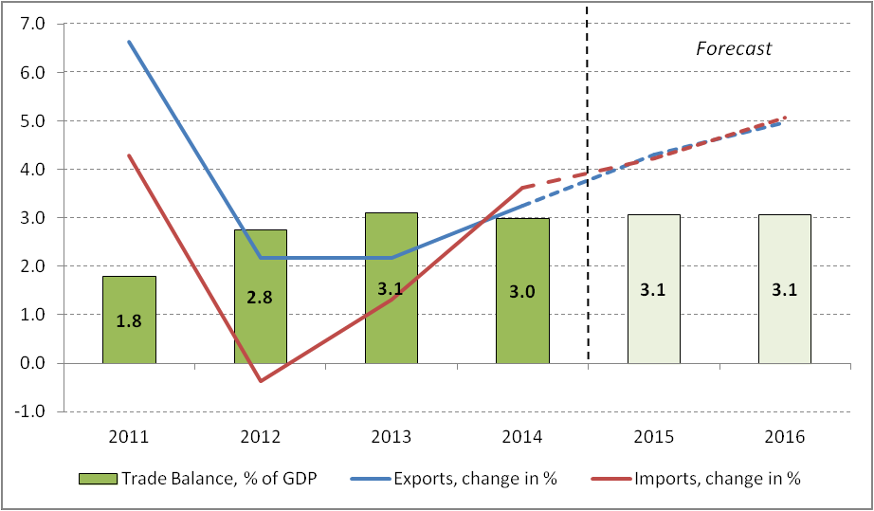
Source: BUSINESSEUROPE’s forecast based on survey of Member Federations & AMECO Database until 2014

Lower oil prices in particular are likely to play an important role in increasing private consumer spending by providing a boost to disposable income. Oil prices are down by about $40 per barrel compared to a year ago, which based on past experience could boost GDP by an extra
0.5 percentage points this year. The rise in car registrations we have seen in the EU in recent months (figure 2) is an important indication of rising consumer confidence, with a significant improvement also observed in recent months in the European Commission’s EU consumer confidence indicator.

Figure 2 Rising car registrations points to improving consumer confidence
Passenger car registrations in the EU, Jan 2013 to March 2015, seasonally adjusted
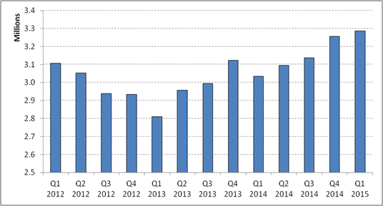
Source: European Automobile Manufacturers Association (ECEA), seasonally adjusted by BUSINESSEUROPE

Improvements in consumer confidence are also feeding through into moderate rises in business confidence. For example, the Economic Sentiment Index (ESI) of the European Commission rose from 102.3 points in February to 103.9 points in March 2015. Our members expect to see improving business confidence levels for both services and particularly industry over the next 6 months (figure 3).

Figure 3 Significant improvements expected for business confidence
Overall business climate in industry and services over next 6 month
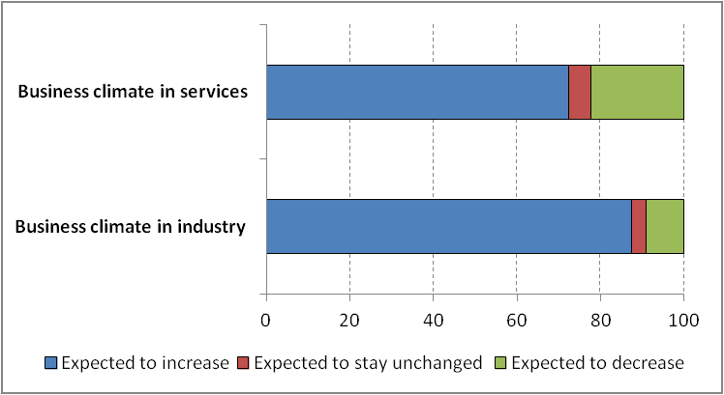
Source: BUSINESSEUROPE’s forecast based on survey of Member Federations

A look at growth drivers as seen by our member federations in more detail (fig ure 4), reinforces the importance of both expected future improvements in consumer expenditure and lower trade - weighted exchange rates in spurring growth. As we consider in more detail below, the moderate improvements in bank lending conditions we have seen in the last twelve months are expected to continue, alongside moderate improvements in labour markets conditions, particularly as selected countries undertake reforms. US growth remains a positive factor, although significantly less than in 2014.

However, growth prospects are still held back by high levels of taxation that need to be reduced through measures to improve the efficiency of public expenditure . Further risks to the outlook identified by members include increasing geopolitical tensions, in particular with Russia, a rapid increase in energy prices or the euro trade-weighted exchange rate well as political reform fatigue. Persisting risks regarding political and economic developments in weak euro area countries continue to create downward risks. Finally a slowdown in emerging market growth could dent EU exports.

Figure 4 Higher consumer spending, lower exchange rates but also more liquidity for banks act as principal growth drivers
Impact of past and expected future changes of different factors on growth forecast
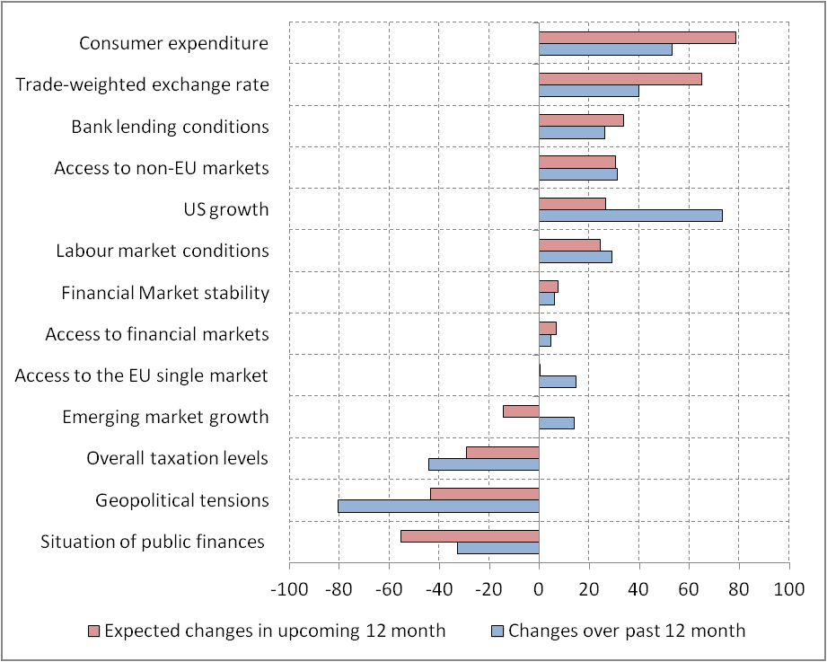
Source: BUSINESSEUROPE’s forecast based on survey of Member Federations

Persistently high unemployment rates remain despite slight decreases

Although unemployment rates are expected to slightly come down in the EU ( to 9.5% in 2015 and 9.0% in 2016 from 10.2% in 2014) and the Euro Area (to 10.6% in 2015 and 10.1% in 2016 from 11.6% in 2014), they still remain unacceptably high. Over the forecast horizon, unemployment remains well above pre-crisis levels (7.5% in the Euro Area and 7.2% in the EU in 2007) which points next to cyclical factors to the persistence of high structural unemployment. Clearly, more product market and in particular labour market reform efforts are required to substantially bring down unemployment rates.

Low inflation rates in 2015 but prices picking up the year after

As figure 5 shows, annual inflation in the Euro Area turned negative in December 2014. A
strong factor in the decline were the falls in energy prices seen from October through to January

(the overall fall in monthly inflation in January is primarily a seasonal effect as retails put products on sale).

Figure 5 Annual and monthly inflation rates came down over the last year
Annual and monthly inflation rates, March 2014 to February 2015
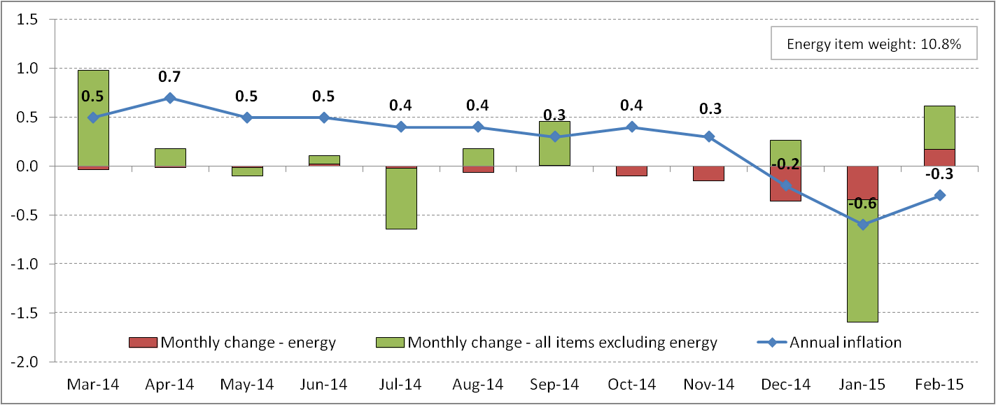
Source: Eurostat

Given that energy accounts for about a tenth of the basket of goods used to measure inflation, a continued stabilisation of energy prices over the coming months would alone lead to an average increase of headline inflation by about half a percentage point by the end of 2015 as the energy price deflation seen last year drops out of the index.

In addition, inflation should further be lifted by the weaker euro exchange rate. The weaker euro increases import prices in euro terms and may thereby lift consumer price inflation, including through second effects of rising intermediate prices. According to a Eur opean Commission estimate, the 9% decline of the euro’s NEER since April 2014 is likely to boost inflation by an extra 0.4 percentage points until the end of this year, with the strongest impacts in Spain (0.6 pp) and Ireland (0.7pp) (Table 2).

Table 2 The lower euro exchange rate will lift some countries’ inflation rates
more than others
Annual and monthly inflation rates, March 2014 to February 2015

 | Impact of 1% euro depreciation on inflation after 3 quarters (in pp) | Actual NEER depreciation (April 2014 to February 2015, in %) | Expected impact from euro depreciation on inflation by the end 2015 (in pp)
Euro Area | 0.05 | 8.9 | 0.4
Ireland | 0.09 | 7.8 | 0.7
Spain | 0.15 | 4.3 | 0.6
Netherlands | 0.08 | 5.2 | 0.4
Belgium | 0.06 | 4.5 | 0.3
Portugal | 0.1 | 2.7 | 0.3
Finland | 0.08 | 2.6 | 0.2
Austria | 0.05 | 3.5 | 0.2
Germany | 0.03 | 5.4 | 0.2
France | 0.03 | 4.9 | 0.1
Italy | 0.01 | 4.5 | 0.0
Source: European Commission

Headline deficits and debt ratios expected to decrease slightly

Annual government deficit levels are expected to further decline in the EU (-2.4% in 2015 and -
2.0% in 2016) and the Euro Area (-2.0% in 2015 and -1.7% in 2016). Falls in the debt-to-GDP
ratio are also expected to gradually decline, provided expected GDP growth is achieved.

2. COUNTRY DIFFERENCES

Competitiveness improvements are bearing fruits

While last year some countries still had negative growth rates, a ll EU Member States are expected to grow again in 2015 (table 3). However, how fragile the economic outlook remains can be seen in the persisting divergence between Member States. Ireland, the three Baltic countries and Poland stand out as very positive examples where high growth rates are expected in the upcoming two years, demonstrating that reforms aimed at reducing competitiveness imbalances are increasingly bearing fruit.

Table 3: All surveyed countries are expected to grow again in 2015 and 2016
Main forecasts for all the economies surveyed 1

Source: BUSINESSEUROPE’s survey of Member Federations
 |  | Real GDP growth |  |  |  | Inflation |  |  |  | Unemployment
% Change |  | 2015 |  | 2016 |  | 2015 |  | 2016 |  | 2015 |  | 2016
Austria |  | 0.8 |  | 1.6 |  | 1.2 |  | 1.8 |  | 5.3 |  | 5.3
Belgium |  | 1.1 |  | 1.4 |  | 0.0 |  | 1.1 |  | 8.3 |  | 8.1
Cyprus |  | 0.4 |  | 1.5 |  | 0.7 |  | 1.2 |  | 15.8 |  | 14.8
Estonia |  | 2.0 |  | 3.3 |  | 0.8 |  | 2.1 |  | 7.8 |  | 7.7
Finland |  | 0.9 |  | 1.3 |  | 0.2 |  | 0.6 |  | 8.8 |  | 8.6
France |  | 1.2 |  | 1.6 |  | 0.4 |  | 1.4 |  | 10.2 |  | 10.1
Germany |  | 2.0 |  | 2.0 |  | 0.8 |  | 1.6 |  | 5.2 |  | 4.8
Greece |  | 1.7 |  | 2.4 |  | -1.9 |  | -0.4 |  | 25.0 |  | 22.0
Ireland |  | 5.4 |  | 4.7 |  | 0.5 |  | 1.5 |  | 9.5 |  | 8.6
Italy |  | 0.5 |  | 1.1 |  | 0.2 |  | 0.6 |  | 12.9 |  | 12.6
Latvia |  | 2.0 |  | 3.2 |  | 0.5 |  | 1.0 |  | 10.5 |  | 10.0
Lithuania |  | 2.6 |  | 3.2 |  | -0.4 |  | 0.5 |  | 9.3 |  | 9.0
Luxembourg |  | 2.6 |  | 2.9 |  | 0.6 |  | 1.8 |  | 6.4 |  | 6.3
Malta |  | 3.3 |  | 2.9 |  | 1.0 |  | 1.9 |  | 5.9 |  | 5.9
Netherlands |  | 1.4 |  | 1.7 |  | 0.4 |  | 0.7 |  | 6.6 |  | 6.4
Portugal |  | 1.7 |  | 1.9 |  | 0.2 |  | 1.1 |  | 12.9 |  | 12.2
Slovak Republic |  | 2.5 |  | 3.2 |  | 0.4 |  | 1.3 |  | 12.8 |  | 12.1
Slovenia |  | 2.0 |  | 1.7 |  | 0.0 |  | 0.6 |  | 9.3 |  | 8.9
Spain |  | 2.8 |  | 2.6 |  | -0.3 |  | 1.4 |  | 22.1 |  | 20.0
Bulgaria |  | 1.6 |  | 2.2 |  | 0.2 |  | 1.4 |  | 11.2 |  | 10.7
Croatia |  | 0.2 |  | 1.0 |  | 0.0 |  | 1.0 |  | 16.8 |  | 16.4
Czech Republic |  | 2.5 |  | 2.6 |  | 0.4 |  | 1.9 |  | 5.7 |  | 5.6
Denmark |  | 1.3 |  | 1.7 |  | 0.5 |  | 1.7 |  | 5.9 |  | 5.5
Hungary |  | 2.0 |  | 1.7 |  | 0.2 |  | 1.5 |  | 7.4 |  | 7.4
Poland |  | 3.6 |  | 3.8 |  | 0.0 |  | 1.4 |  | 7.8 |  | 7.5
Romania |  | 2.7 |  | 2.9 |  | 1.2 |  | 2.5 |  | 6.9 |  | 6.8
Sweden |  | 3.1 |  | 2.6 |  | 0.2 |  | 1.0 |  | 7.5 |  | 7.5
United Kingdom |  | 2.7 |  | 2.6 |  | 0.4 |  | 1.8 |  | 5.4 |  | 5.2
Norway |  | 0.8 |  | 1.8 |  | n.a |  | n.a |  | 4.0 |  | 4.0
Turkey |  | 3.7 |  | 4.0 |  | 6.3 |  | 5.8 |  | 10.5 |  | 10.5
Iceland |  | 2.3 |  | 2.5 |  | 2.3 |  | 2.8 |  | 4.3 |  | 4.0

1 Note that for blank surveys we used figures from the Winter forecast of the European Commission. This is the case for
Malta, the Netherlands, Slovakia, Romania, Iceland and Turkey as well as the 2016 estimates for Germany and Sweden.

Unemployment rates remain highly uneven across Member States. Some limited convergence is expected though, as those Member States that currently have the highest unemployment rates are also expected to see the greatest reductions (e.g. Greece, Spain, Ireland and Portugal as shown in figure 6).

Figure 6 Countries’ unemployment rates remain highly uneven despite falls in the countries with the highest rates
Unemployment rates 2014-2016, selected EU countries
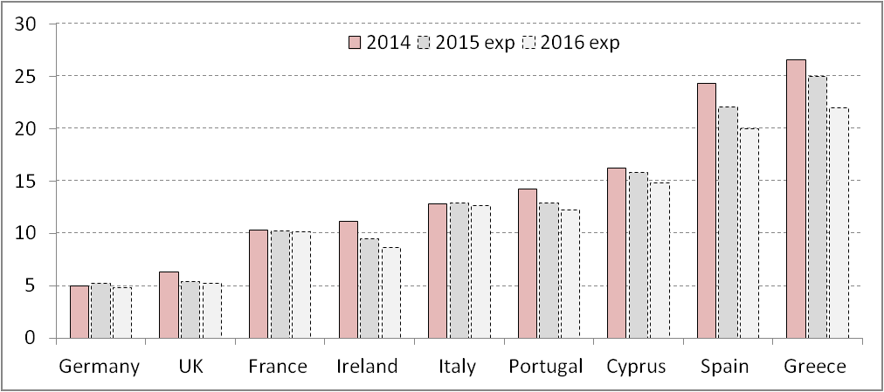
Source: BUSINESSEUROPE’s forecast based on survey of Member Federations

BOX 1: Impact of recent exchange rate changes on exports and output

This box takes a more detailed look to what extent exchange rates changes over the last year are likely to impact on EU and Euro Area Members’ exports and final output. Our analysis indicates the following:

➢ Over the last year, we saw a significant depreciation of nominal trade-weighted exchange rates for the Euro Area (-12%), Sweden (-9%) and Norway (-9%). In contrast, the trade-weighted exchange rates of the UK and Switzerland increased by around 5% and 12%, respectively.

➢ For the Euro Area overall, GDP could increase by up to an extra 0.5% this year and by up to 0.4% in
2016 as a result of the boost to exports from the lower euro.

➢ Both the extent of the depreciation and its impact will differ between Euro Area countries due to different trading patterns, overall export exposure and the sensitivity of exports to price changes.

o Ireland has seen one of the strongest effective exchange rate depreciation as a result of its strong trade links with both the UK and the US whose currencies have strengthened significantly. This contrasts with the Baltic States and Finland who all have strong links with the weakening Russian economy.

o Ireland (37.5%), Luxembourg (34.2%) and Estonia (28.8%) have the highest shares of domestic value-added going towards extra-euro exports, while Greece (9.6%), Portugal (9.4%) and Spain (9.3%) have the lowest shares.

o Portugal and Italy have the most price sensitive exports, in contrast to Belgium and the
Netherlands.

o But those countries with the most price sensitive exports tend to have lower extra-EU export exposure, reducing the overall difference of a similar real effective exchange rate change within the euro area.

1) Recent changes in countries’ effective exchange rates

Over the last year, we have seen significant movements in exchange rates within the EU (figure 7). Whilst the majority of our members operate from the Euro Area, which has seen a 12% depreciation in its trade- weighted nominal exchange rate, businesses in Sweden (-9%), Norway (-9%), and to a lesser extent, Denmark (-3%) and Poland (-3%) have also seen a fall in the external value of the currency. In contrast, the trade-weighted exchange rates of the UK Pound and the Swiss Franc increased by about 5% and 12%.

A closer look at bilateral exchange rates for the Euro Area shows that the euro’s depreciation has been strongest against the US Dollar and the Yuan, whilst in contrast, the economic and political situation in Russia has led to an appreciation of the euro by 30% against the Rouble.

Figure 7 Significant changes in EU exchange rates over the last year
Nominal effective and bilateral exchange rate movements (01 April 2014 – 01 April 2015)

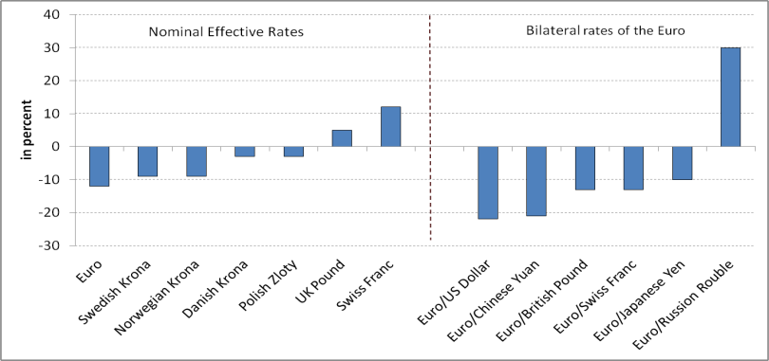Source: Bank of International Settlement (BIS), European Central Bank, Bank of England

As a consequence of countries’ different trade patterns, there have been significant country differences in the nominal effective exchange rate (NEER) between Euro Area (EA) countries (fig 8). For example, the strong trade ties of the three Baltic countries and Finland with Russia, contributed to an appreciation of the NEER for Latvia and Lithuania and to a less significant depreciation for Estonia and Finland. In contrast, Ireland, with strong trade relations to the US and UK, experienced one of the most significant falls in the NEER of all EA countries.

Relatively low inflation in euro area has also contributed to the real effective exchange rate (REER)
depreciation being slightly stronger than for the NEER.

Figure 8 Significant country differences regarding effective exchange rates changes
Real and nominal effective exchange rates, % change April 2014 – February 2015

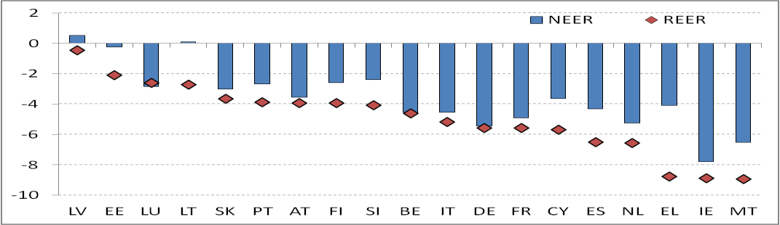Source: Bank of International Settlement (BIS)

2) Impact of exchange rate changes on Euro Area members’ export volumes

In general, a lower (real) exchange rate should benefit economies both by lowering the relative prices of foreign exports and by making imports more expensive, encouraging domestic consumers to switch from foreign goods to products made at home (although there might be a negative impact in the longer-term on export performance in specific economies if the depreciation reduces the incentives to maintain competitiveness). In this box, we focus primarily on the effect on exports.

As noted above, the change of effective exchange rates differs within the Euro Area according to Member
States’ trade patterns. But the impact on exports of a given change in the REER will depend upon both:

• trade openness - the relative size of (extra-Euro Area) exports to GDP (“trade openness”) and the
share of domestic value-added in Members States’ (extra-Euro Area) exports, and;

• export sensitivity - the extent to which a lower exchange rate affects volumes of exports sold.

2a) Trade openness and domestic value-added

Figure 9 shows that there are great differences between euro area countries in the extent to which they are open to trade outside of the euro area. Slovakia has a 47% share of extra-Euro Area exports to GDP, whereas Cyprus’s (5%), Luxembourg’s (8%), Greece’s (10%), and France’s (10%) shares are relatively low.

Figure 9: Some Euro Area countries are much more open to external Euro Area trade than others
Extra-Euro Area exports of goods as % of GDP, 2014

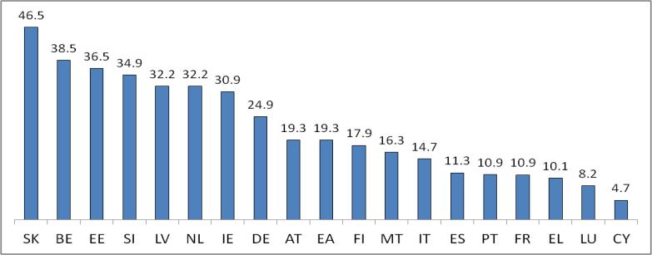Source: Eurostat

However, with the growth of international value chains, simply looking at exports as a share of GDP can be misleading if a large part of a country’s exports is imported components (e.g. the country may have a large amount of assembly activity). New data has now been developed which seeks to look at the actual value- added undertaken in a country which is incorporated in its exports. Figure 10 showing the adjusted data (albeit for an earlier year) suggests that a significant part of extra-euro area exports in countries such as Slovakia and Belgium may be re-exports of imports from elsewhere in the euro area. According to this measure, Ireland has the largest share of value-added which goes outside the euro area.

Figure 10 Domestic value-added in extra-Euro Area exports* as % of GDP, 2009

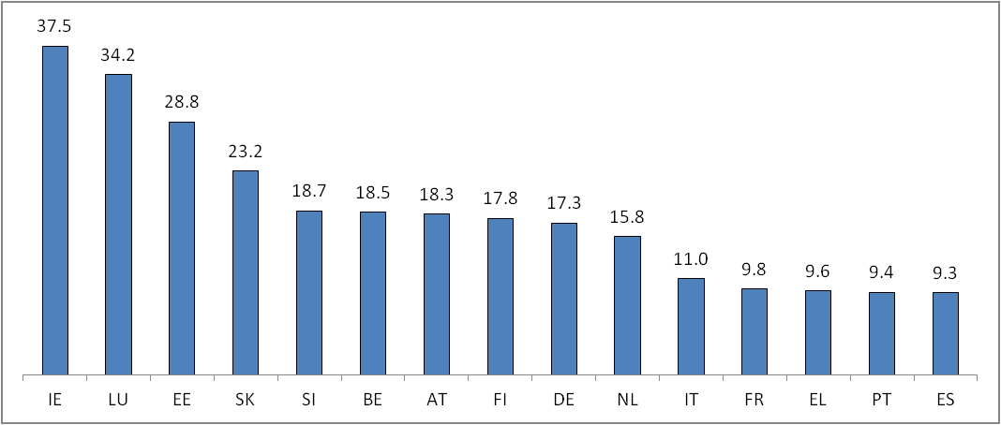Source: OECD2; *Euro Area excludes Cyprus, Latvia, Lithuania and Malta

2b) Export sensititivity

The extent to which exchange rate movements impact on Member States’ volumes of exports sold (“export elasticity”) also varies significantly across Euro Area Member States (figure 11). The Commission analysis presented suggests that exports from Italy and Portugal are significantly more price sensitive than those from Belgium and the Netherlands.

Differences in export elasticity can be related to country differences in the product structure of exports. Exports of homogeneous products are generally more reactive to exchange rate movements compared to differentiated products. For instance, the advanced technological level, for example in the car industry, may to some extent explain the relative immunity of German exports to fluctuations in the euro exchange rate. Portugal’s, Spain’s and partly Italy’s exports contain relatively low proportions of capital goods (that tend to have fewer close substitutes) which could explain the countries’ higher elasticity levels. Yet, the cases of Ireland, France and Austria which either have a high proportion of exported services in total exports (generally more differentiated than goods) or high proportions of capital goods suggests that other factors
also play a role when comparing cross-country elasticities.3 4

2 Note that Eurostat provides data for extra-Euro Area exports of goods while the OECD estimates value-added for foreign final demand (i.e. it includes services). Thus Figure 9 and 10 are not directly comparable.
3 For more details see European Commission, Quarterly Report on the Euro Area Volume 13 (2014) Issue 3.
4 For completeness, one should note that import substitution and the extent to which rising or falling exports affects domestic demand and thereby imports also matters when assessing the impact of exchange rate fluctuations on the economy. While econometric estimates yielded disappointing results, the Commission suggests that import price
elasticities for European countries are significantly lower than their export price elasticities.

Figure 11 Euro Area countries exports have different price sensitivities
Long-run estimates of impact of a 1% depreciation in the REER on export volumes in %

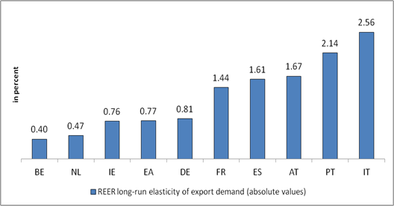Source: European Commission

2c) Overall export sensitivity to exchange rate movement

In order to fully assess to what extent a given REER depreciation affects the scale of value-added Euro Area members will export outside the single currency area, we need to look at export elasticity and domestic value-added together. Figure 12 suggests that country differences in export growth from a given REER exchange rate depreciation may be relatively limited given the tendency for those countries with the most price sensitivity to have relatively limited extra-EU export exposure (e.g. Portugal and Italy show a relatively low share of domestic value-added in extra-Euro Area exports). Such an observation would be consistent with the expectation that companies producing highly differentiated products for niche markets which have limited price sensitivity are more likely to be exporting outside of the EA.

Figure 12: Countries with highly price sensitive exports generally have less exposure to trade outside the euro area
Export elasticity and domestic value-added in foreign exports as % of GDP

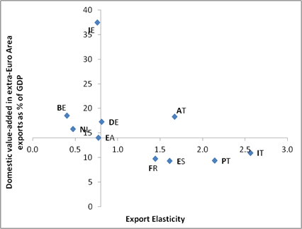Source: ECB, Eurostat, European Commission

3. INVESTMENT AND ACCESS TO FINANCE

Access to finance has been a key concern in recent years. While we see improvements in access to finance for businesses (figure 13), supported by an increasingly active European Central Bank, the concern remains that as demand for finance picks up, insufficient finance becomes an increasing barrier to firms’ investment.

Figure 13 Members anticipate some improvement in financing conditions
Supply for finance for coming 6 months compared to last 6 months

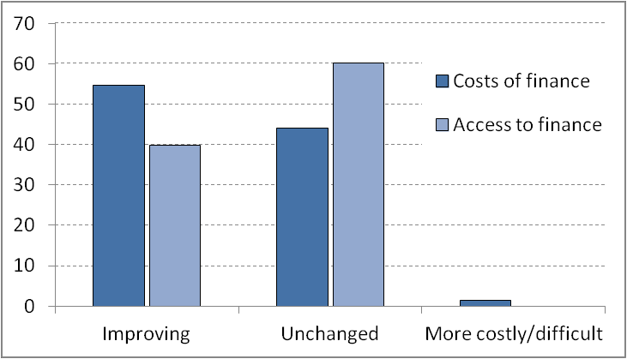Source: BUSINESSEUROPE’s forecast based on survey of Member Federations

Improvements in the supply of finance are expected due to improved capital and liquidity position of European banks. But we remain concerned that overly burdensome financial regulation is likely to be an obstacle to the supply of finance (figure 14). Financial regulation needs to find the right balance between improving financing stability and supporting investment.

Figure 14 Financial regulation acts as major obstacle to supply for finance
Supply factors for coming 6 months compared to last 6 months

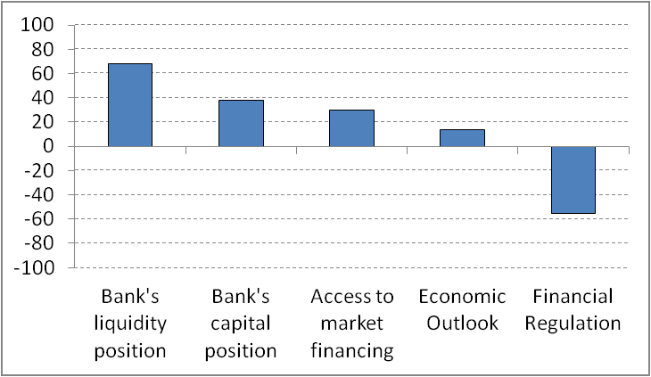Source: BUSINESSEUROPE’s forecast based on survey of Member Federations

This is consistent with the latest ECB bank lending survey from April which reports a slight net easing of credit standards on loans to companies, albeit from a level that is extremely tight in historical terms.

On the demand side, in line with improving domestic demand, businesses reported the highest level of demand for finance since the start of the crisis (figure 15).5

5 BUSINESSEUROPE asked Members about their view on companies’ demand for finance for the first time in autumn
2011.

Figure 15 Highest level of business demand for finance in the last four years
Demand for finance for coming 6 months compared to last 6 months, Autumn 2011 to Spring 2015
Economic Outlook

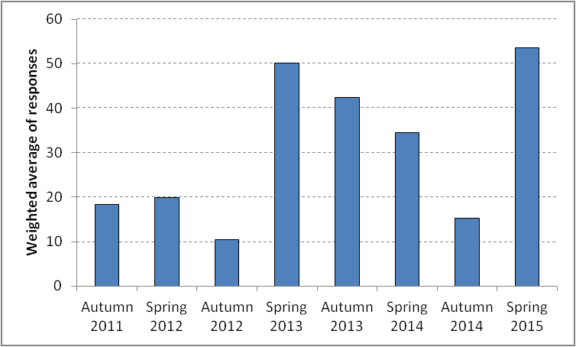Source: BUSINESSEUROPE’s forecast based on survey of Member Federations

Our survey indicates that we are likely to see a pick-up in business investment both in industry and services as displayed in figure 16 (for the industrial sector a weighted average of 89.4% of respondents expect an increase, while for services a weighted average of 73.3% expect an increase). Overall, we foresee investment growth of 2.8% in 2015 and 3.8% in 2016.

Figure 16 Businesses in industry and services planning more future investment
Investment trends over the next 6 month compared to the last 6 months

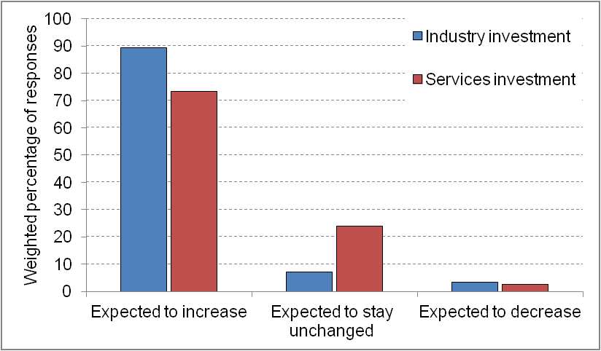Source: BUSINESSEUROPE’s forecast based on survey of Member Federations

In more detail, figure 17 notes that improvements in business investment are first and foremost influenced by improvements in domestic and global demand, the profitability of investment projects as well as the moderate improvements in the cost of finance.

Figure 17 Domestic and global demand and profitability of projects as key investment drivers
Factors influencing investment decisions of businesses

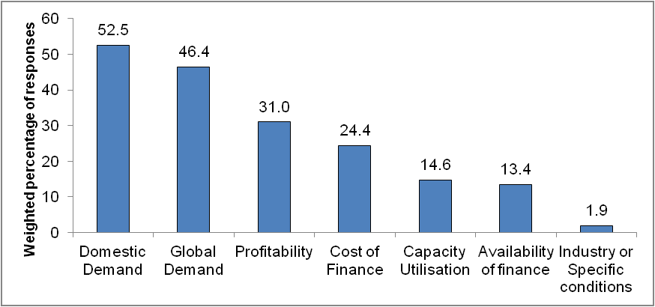Source: BUSINESSEUROPE’s forecast based on survey of Member Federations

The expected increase in investment would also be consistent with recent data on capacity utilization. Capacity utilization in the manufacturing sector increased by 0.8 percentage points from Q1 2014 to Q1 2015 as displayed in figure 18 and is now the highest level since Q4 2011.

Figure 18 Increasing capacity utilization consistent with higher investment spending
Capacity utilization in EU manufacturing industry, Q1 2010 – Q1 2015

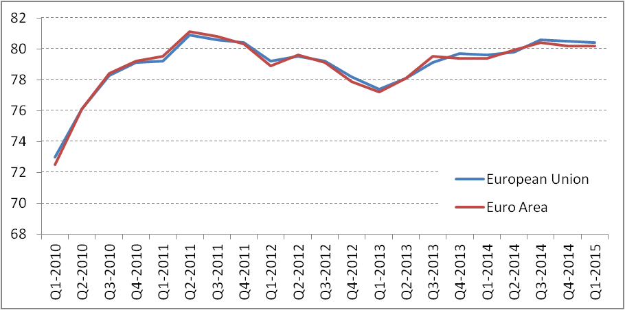Source: Eurostat

In summary, the expected improvement in the economy and the accompanying increase in demand for finance are likely to further highlight structural weaknesses regarding access to finance in the EU. Whilst bank lending availability has improved slightly in recent months, lending alone remains inadequate to fully address the EU’s huge investment needs. In addition to ensuring financial regulation supports both stability and lending, the EU must also improve non-bank financing sources to improve access to finance. In this context, we particularly welcome the Commission’s Green Paper for a Capital Markets Union, including proposals to support the expansion of properly regulated securitisation.

